Kimble Named President and CEO
of Schöck North American Operations

Adam Kimble has been named CEO of Schöck USA Inc. and President of Schoeck Canada, Inc. by the Board of Directors of Schöck Bauteile GmbH, Baden-Baden, Germany.

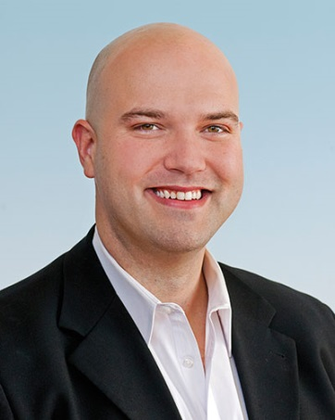
Adam Kimble
CEO, Schöck USA Inc. and
President, Schoeck Canada, Inc.
Kimble will have responsibility for managing the focus and growth of Schöck's North American operations, which centers on educating the building industry on thermal bridging solutions in multi-story buildings using the company's line of Isokorb® structural thermal break products.

He joined the company in 2012 as Regional Sales Manager of the Midwest, and in 2014 was appointed to Head of Sales and Marketing,

"My mission is to support our team of sales engineers in providing Commercial Architects, Structural Engineers, Developers and Contractors with the technical support and advanced products they need to save energy, prevent mold and improve building comfort," explains Kimble.

Asked about building insulation trends, he says, "Future energy efficiency regulations will specify increasingly higher insulation requirements throughout the building envelope, especially at balconies, parapets, canopies and other structural penetrations responsible for significant heat loss when not insulated," adding, "I fully expect ASHRAE, the International Code Council, the U.S. Department of Energy and other regulatory agencies to specify that building envelopes be insulated at balconies and other structural penetrations as an explicit code requirement."

Chris Willett, Regional Director of the UK and North America for Schöck remarks, "Adam will enrich our senior management team by spearheading the expansion of the U.S. and Canadian markets. His leadership style and extensive experience puts him in an excellent position to lead us to success, while bringing greater awareness of both the problem and the solution."

Kimble holds degrees in both Civil Engineering and Business Administration from the University of New Orleans.

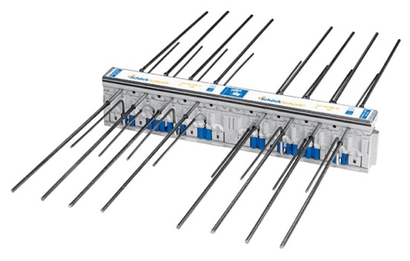
Isokorb® structural thermal break products for concrete (shown) and steel construction prevent thermal bridging by providing both insulation and structural support at building envelope penetrations.

Shöck Bauteile GmbH, founded in 1962 by Eberhard Schöck, is the world leader in structural thermal break technology and manufacturing. The company's Isokorb® product lines for concrete and steel construction simultaneously support and insulate structural breaks in commercial building envelopes, reducing heat loss by up to 92 percent while preventing mold formation and improving comfort.

–-END—
Marketing Contact for
Schöck North America:
Tracy Dacko, Marketing Manager
281 Witherspoon Street, Suite 110
Princeton, NJ 08540
+1-609-592-2565
Tracy.Dacko@Schoeck.com

Press Agency Contact for
Schöck North America:
Susan Schaaf, Rapp Advertising, Inc.
150 Morris Avenue, Suite 200
Springfield, NJ 07081-1315
+1-973-467-5570 x118
sschaaf@rappadvertising.com

